Final Paper
Ellie Bair
LIS 540

Keywords, Semiotics and Image Searches


Image A Image B

An art buyer for a design company is working on a print ad for a big client. Unfortunately, the client has left very little money in their budget to shoot pictures for the ad. So, the buyer turns on her computer and navigates to the Punchstock website. She has had luck finding good pictures at this website before, and she thinks that she will be able to come up with something that will fit in well with both the client’s budget and design. She needs to find a picture of a strong, sturdy tree, because the client wants to convey their permanence and reliability. So, she types the word “tree” in to Punchstock’s keyword search engine and hits enter. The two images above are returned in the first couple rows of results. The buyer looks briefly through the returned results, and decides that none of these images are what she is looking for, and besides, not all the pictures seem to be particularly related to trees. She tries a few other word combinations like “strong tree” or “old tree” and gets similarly irrelevant results. She decides that Punchstock probably doesn’t have the picture she is looking for - or at least she can’t find it – and she decides to look at another stock photo company.
This scenario illustrates a common disconnect in the stock photography industry. Both image A and image B do contain a tree, but the user found them to not be relevant to her need. However, the person who applied the keywords to the images felt that the word “tree” was necessary in order to fully describe all the elements of both pictures. The images, or information objects, have not changed, yet both the user and the keyworder glean different information from them. This situation suggests that there is a strong perceptual component to information, which has serious implications for information retrieval systems. If there is no way to predict what information a person might perceive to be important or relevant from an information object, then it becomes virtually impossible to build an information retrieval system which will provide positive results on a consistent basis. Fortunately, structuralism provides a theoretical basis which lets us begin to attack the problem of information perception.
However, before we attempt to understand the relationship between perception and information, it would be helpful to define exactly what information is. Unfortunately, the precise definition of the term information is still widely debated. Information scientists such as Buckland (1991) and Bates (2006) focus mainly on the objective nature of information. Even though they acknowledge the subjective component of information, they argue that it is more fruitful to study the tangible components of information. Others, such as Hjørland (2007) argue that exploring the subjective nature of information is necessary and important, even if it is “frustrating and difficult.” Some, such as Furner, (2003) posit that we should abandon the concept of information all together, and substitute it with more easily definable characteristics, such as relevance. Others, including Donald Case argue that instead of simply abandoning the concept of information, we should adopt an extremely broad definition of information as “any difference that makes a difference.” This definition allows us to make an inclusive study of information without differentiating as to its’ subjective or objective nature (2007, p. 66). Indeed, it seems that the subjective and objective natures of information cannot be separated even as they are unique, as one invariably references the other. The dual nature of information as both subjective and objective has obvious parallels to semiotics, and the work of linguist Ferdinand de Saussure (Raber & Budd, 2003).
As a structuralist, Saussure was concerned with studying the system of language, and the relationships between the system’s individual components. In this theory, the basic unit of language is the sign, which itself is composed if the signifier and the signified. The signified is the concept or thing that is represented by the signifier, which is the “sound image” or psychological mark a word’s sound makes upon the hearer’s mind. The relationship between the signifier and the signified is arbitrary; there is nothing intrinsic about the signified that relates it to the sound used to represent it. However, the signifier cannot be separated from the signified, and the meaning of a sign exists in the relationship between the signifier and signified. Signs are situated within the wider language system through social interaction, and collective agreements on meanings and rules. In addition, signs are defined in opposition or in agreement with other signs. These positive or negative relationships between signs are known as the value, or the meaning derived through comparison of signs. Over time, meanings of particular signs evolve and change, and necessarily affect the meanings of other signs through their value relationships (Klages, 2001).
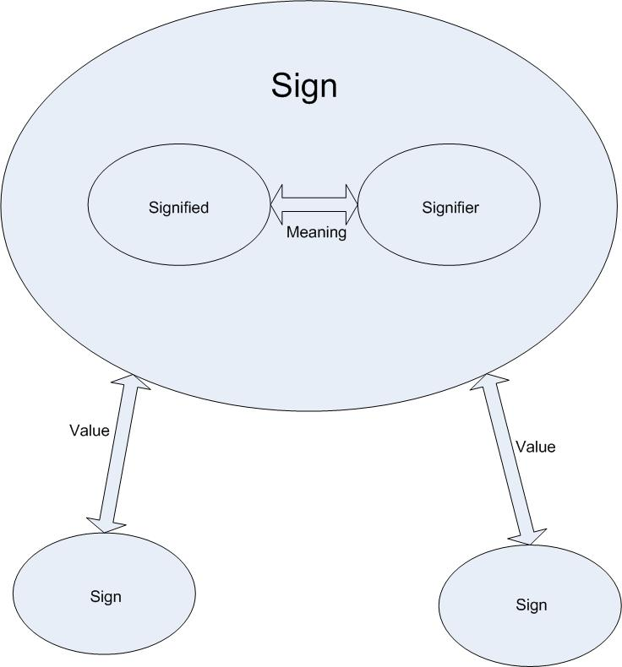
Fig. 1: Visual representation of Saussure’s language system
This theory of language can be easily applied to the structure of information systems. An information object can be defined as the union between the text (signifier) and content (signified). It is in the union between the two that one derives meaning. Information objects are also evaluated in relation to other information objects (value), and this can cause change in the relationships between the text and the content and therefore a shift in meaning. Or, as explained by Raber & Budd (2003),
As a signifier, the text remains constant, but as a signified the content changes as the viewpoint brought to bear on the informative object changes. This changing relation between text and content, and between signifier and signified constitutes change in the meaning of the informative object, as new meanings are assigned to existing objects (p.512).

It is also possible to further refine this and relate it directly image searching with keywords. The keyword is the signifier, representing the concept or idea that the user is looking for. Alternately, the keyword is also the signifier to the information in an image that is perceived by the person applying keywords to that image. If the keyword search is then viewed as a system of exchanges between signifiers and signifieds, it can be viewed as a mechanism for relating a user’s idea or concept to a keyworder’s perception of an image. If the user’s concept and the keyworder’s perception match, the user will be returned images that are relevant to their need. The relevance of a image returned in a keyword search is analogous to a sign’s value. If the keyworder’s perception does not match the user’s concept, a failure of the system will occur as is illustrated in the opening example.
Figure 2: Visual representation of exchanges in a keyword search
So, this leads to the question, what would cause a failure in the keyword search system, or a disconnect between the keyworder’s perception and the user’s concept? The answer can be stated very simply: context. If the keyworder does not share a context, it is highly likely that the keyworder’s perception will not match well with the user’s idea. When a keyworder is operating in a different context than the user, the keyworder does not have an understanding of the rules of the user’s system, i.e. culture, or a communally agreed perceptual system and language. For example, images outsourced to India for keywording often come back with keywords that are sub-standard in an American, English-speaking context. Some examples of such keywords are “remote controlling,” “make-up brushing” and “recreating, recreation” appear (E. Bair, Personal memo, June 29, 2007). Or alternately, it is often the case that a separate set of keywords must be created when sending images to the British market, as images keyworded within an American context will cause a higher percentage of search failures when used in the UK. For example, the keyword “dog collar” is appropriate to use when keywording an image of a clergyman for the UK market, but it can be seen as offensive if used in the American context. From this, one can then conclude that in order to maximize the amount of keyword search successes, images must be keyworded by someone operating within or with extensive knowledge of the context of the target market.
The success of an keyword search system is absolutely essential to the existence of the stock photography business. If the keyword search fails, and a user is returned images that they find to be irrelevant, they will go elsewhere for their imagery, which amounts to a direct loss of revenue. By using a structuralist viewpoint, one can clearly identify the semiotic processes at work when a user goes to perform an image search. It also becomes clear just how reliant the success of a search is on context and an agreed system of perception. By making sure an image’s keywords are appropriate within the context of the market, the likelihood that a user’s concept and the keyworder’s perception will be similar is maximized. This then results in an increase of keyword search successes, which results in more image sales, and improved profits for the stock photo agency.
Works Cited
Bates, M. J. (2006). Fundamental forms of information [Electronic version]. Journal of the American Society for Information Science and Technology, 57(8), 1033-1045.

Buckland, M. K. (1991). Information as thing [Electronic version]. Journal of the American Society for Information Science, 42(5), 351-360.

Case, D. O. (2007). Looking for Information (Second Ed.). Amsterdam, Netherlands: Elsevier.

Furner, J. (2004). Information studies without information [Electronic version]. Library Trends, 52(3), 427-446.

Hjørland, B. (2007). Information: Objective or subjective/situational? [Electronic version]. Journal of the American Society for Information Science and Technology, 58(10), 1448-1456.

Klages, M. (2001). Structuralism and Saussure. Retrieved December 1, 2007 from University of Colorado, English Department, English 2010: Modern Critical Thought Web site: http://www.colorado.edu/English/courses/ENGL2012Klages/saussure.html

Raber, D. & Budd, J. M. (2003). Information as sign: semiotics and information science [Electronic version]. Journal of Documentation, 59(5), 507-522.

